**Leaning Tower of Pasta**

Using spaghetti and marshmallows, students experiment with different structures to determine which ones are able to handle the greatest amount of load. Their experiments help them to further understand the effects that compression and tension forces have with respect to the strength of structures. Spaghetti cannot hold much tension or compression; therefore, it breaks very easily. Marshmallows handle compression well, but do not hold up to tension.*This engineering curriculum aligns to Next Generation Science Standards (*[*NGSS*](https://www.teachengineering.org/standards/ngss)*).*

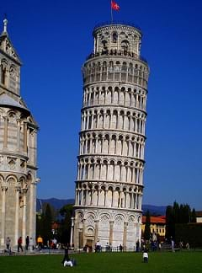

Students investigate compression and tension forces and examine their affect on the strength of structures

Engineering Connection

Engineers consider tension and compression forces when designing a building or structure, and choosing the materials to build it. All structures must be able to handle the forces that act upon them so they will not fail and injure people, wildlife or the environment. Like all structures, the foundation, frame and joints of a skyscraper must be able to withstand enormous tension and compression forces — from the weight of its own materials, the load of people and equipment it holds and the impact of natural forces such as wind, snow and earthquakes.

Learning Objectives

After this activity, students should be able to:

* Describe how compression and tension affect the stability of a structure
* Compare their model to others to understand why some models are stronger than others
* Use number sense to correlate the strength of a structure to the amount of weight it holds
* Explain why engineers consider tension and compression forces when designing and choosing the appropriate materials for a building or structure

Educational Standards

 NGSS: Next Generation Science Standards - Science

[Common Core State Standards - Math](https://www.teachengineering.org/activities/view/cub_mechanics_lesson10_activity1)

[International Technology and Engineering Educators Association - Technology](https://www.teachengineering.org/activities/view/cub_mechanics_lesson10_activity1)

[State Standards](https://www.teachengineering.org/activities/view/cub_mechanics_lesson10_activity1)

[**Suggest an alignment not listed above**](https://www.teachengineering.org/activities/view/cub_mechanics_lesson10_activity1)

Materials List

Each group needs:

* 20 unbroken pieces of uncooked, long pasta, such as spaghetti, linguine or fettuccine
* 30 small marshmallows
* Measuring tape or ruler
* Weights or small books

Worksheets and Attachments

[Standing Strong Worksheet (pdf)](https://www.teachengineering.org/content/cub_/activities/cub_mechanics/cub_mechanics_lesson10_activity1_worksheet.pdf)

Introduction/Motivation

Have you ever wondered how really tall buildings stay up? Why do skyscrapers not fall down when wind hits them? Engineers work with architects and scientists to understand what makes materials break, and then use what they learn to design strong structures. Today, you will have the opportunity to figure out how to make a strong structure, too. Sometimes, engineers may be able to find very strong materials, but they cannot use them in a structure because the materials are too expensive. Sometimes, engineers cannot use as much material as they might like due to budget or supply limitations. Just like an engineer, today you will be constrained; you can only use a limited amount of materials. Your job is to design and build a structure that is as tall and strong as possible, using only marshmallows and spaghetti.

As you build, think about what forces will be acting upon your structure. Which parts will be pushed together — that is, which will experience compression — and which parts will be pulled apart — that is, which will be under tension. Is it better to have a piece of spaghetti or a marshmallow under tension? Under compression? How will you design the tallest, strongest structure using limited resources?

Procedure

**Before the Activity**

* Copy a Standing Strong Worksheet for each group.

**With the Students**

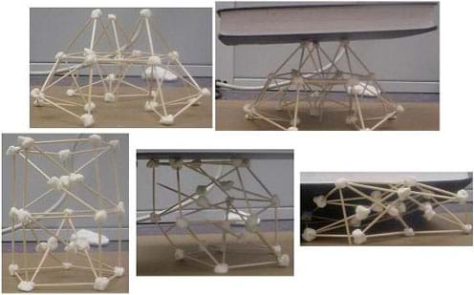Figure 1. Some structures are strong.... and, some are not.

copyright

1. The object of this activity is to build a tower as high AND as strong as you can using only a limited supply of spaghetti (or linguine or fettuccine) and marshmallows. There are no step-by-step instructions for this project, only the constraints of limited resources! Students can do whatever they want with the materials to try to build a structure as tall, stable and strong as possible. The project can be made more difficult by adding more constraints such as fewer materials, a minimum height requirement, or a requirement to support at least a minimum weight for a given time. Let the student teams' imagination, creativity and ingenuity run wild.
2. Hold a competition and give points for how tall the structure is as well as how much weight it can hold. A good way to comparatively measure the effectiveness of each structure is by having students take the load the structure can support and divide it by the weight of the structure. The higher this number, the more effective the structure. For example, 30g (maximum weight structure could hold) divided by 10g (weight of structure alone) = 3.
3. Before testing the structures (see Figure 1), have students measure and record the height and weight of their structure.
4. How much weight does the structure support? Five grams? 10 grams? 20 grams? 30 grams? Have students record their structure's maximum weight held on the worksheet, and calculate the load to weight ratio for comparison purposes.
5. As a class, graph the amount of weight each structure held vs. how much each structure weighed as well as the height of the structure. Discuss different trends and use the graph to lead into the other discussion questions.
6. After the competition, hold a class discussion:
   * Discuss which structure was the tallest and held the most weight. Which structures had the highest ratio of load to structure weight? Which structures held the most weight, regardless of height and the success or failure of the materials used. Spaghetti cannot hold much tension or compression; therefore, it breaks very easily. Marshmallows handle compression well, but do not hold up to tension, and why.
   * Discuss the success or failure of the materials used.
   * Which geometric shapes seemed the strongest for holding weight — triangles, squares, or circles?

Assessment

**Pre-Activity Assessment**

*Discussion Question:* Solicit, integrate and summarize student responses.

* Have you ever built a tower? What did you use for the material(s)? How strong was it? How did you know it was/was not strong?

**Activity Embedded Assessment**

*Worksheet:* Have the students complete the activity worksheet; review their answers to gauge their mastery of the subject.

*Pairs Check:* After student teams finish their worksheets, have them compare answers with a peer group, giving all students time to finish the worksheet.

**Post-Activity Assessment**

*Class Presentations:* Have the student groups take turns presenting the structures to the rest of the class. Ask them to explain where the forces of tension and compression are taking place. Have the class determine which shapes seem to be the strongest for holding up weight.